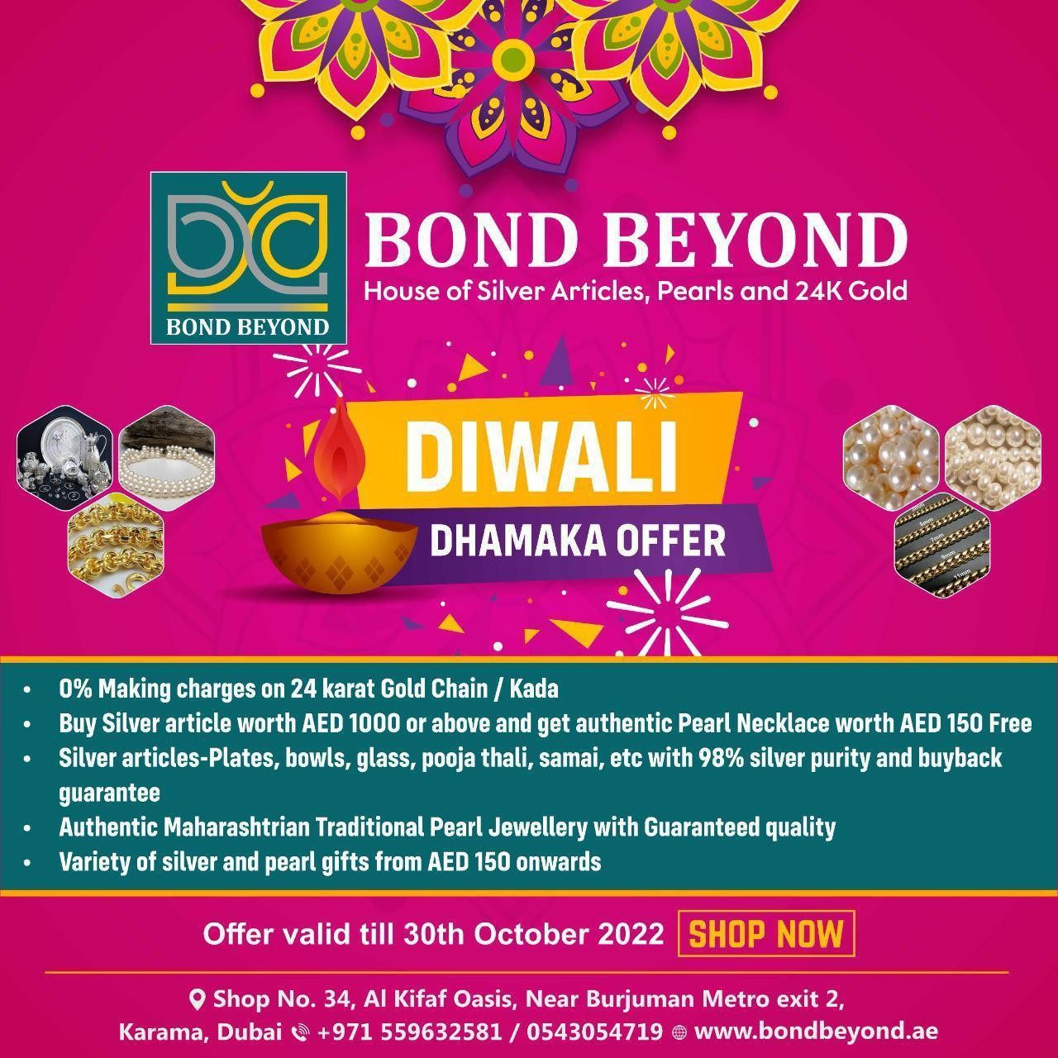

**House of Silver, Pearls and 24K Gold**

**Diwali Offer**

* **Free home delivery upon purchase of AED 1000 or above**

**Contact +971 521221321**

* **AED 150 worth pearl necklace free on purchase of AED 1000 or above Silver article**
* **0% making charges on 24k Gold chain, Bangle, Kada**

*Bond Beyond is a luxury silver collection with fine designs and assured quality ie last*



*Silver is rare, limited and the investment value it carrles drives the importance from*

*oges. ThP Unlque quality, elegance and affordability makes it fall in love for any*



*Bond Beyond iS a one stop destination for silver collection from traditional to modern,*

*budgeted to Customized articles with certified quality to add value now and beyond.*

*It offers wine range of silverwares such as plates, bowls, spoons, forks, gloss,*

*exquisite center pieces, tableware, photo frames, coins, jewelry, decorative items and*

*many other gift articles which are Unique, elegant and unparallel with a high quality*



Range of Products - Pooja Articles

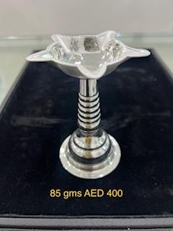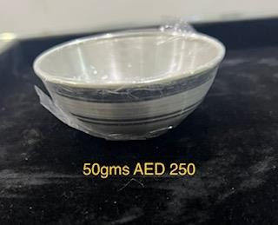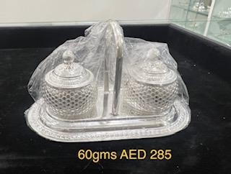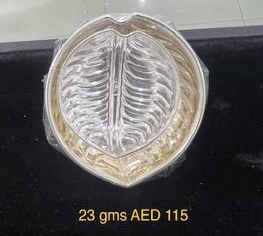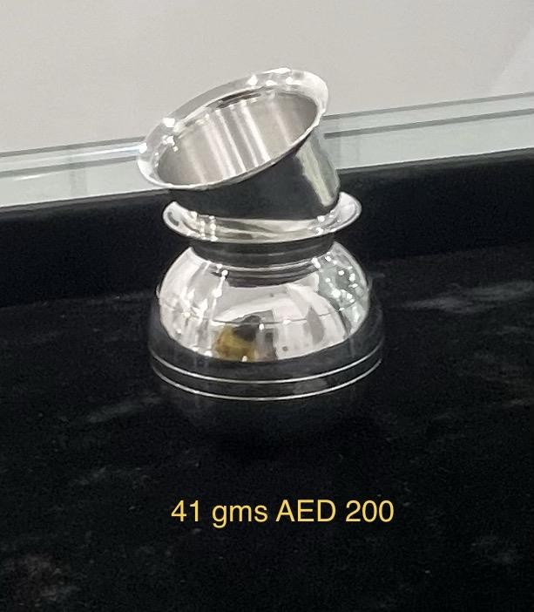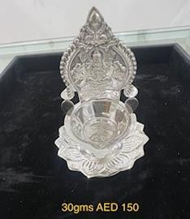

Range of Products - Pooja Articles

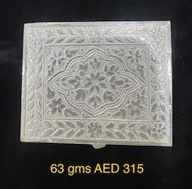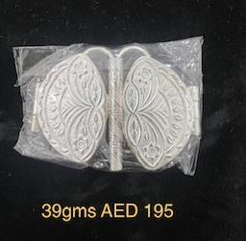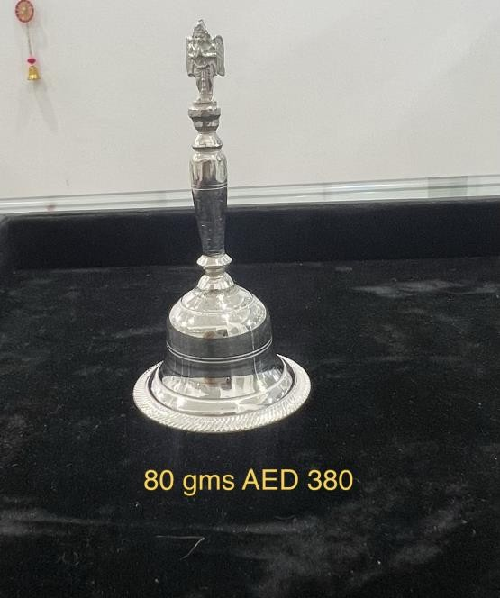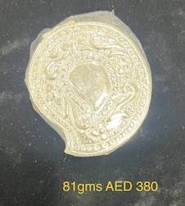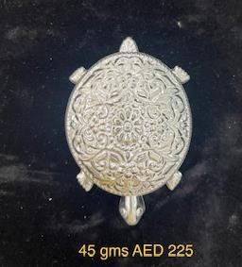

Range of Products - Coins

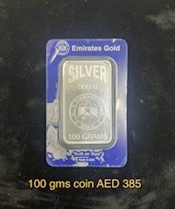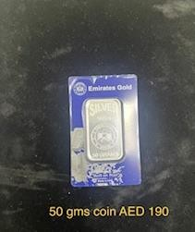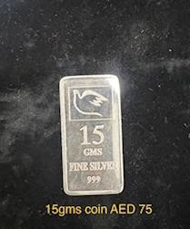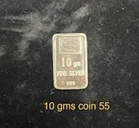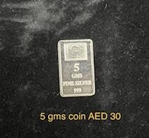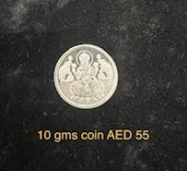

Range of Products

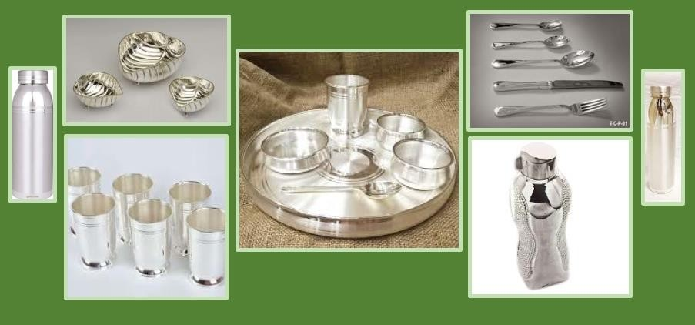

Range of Products

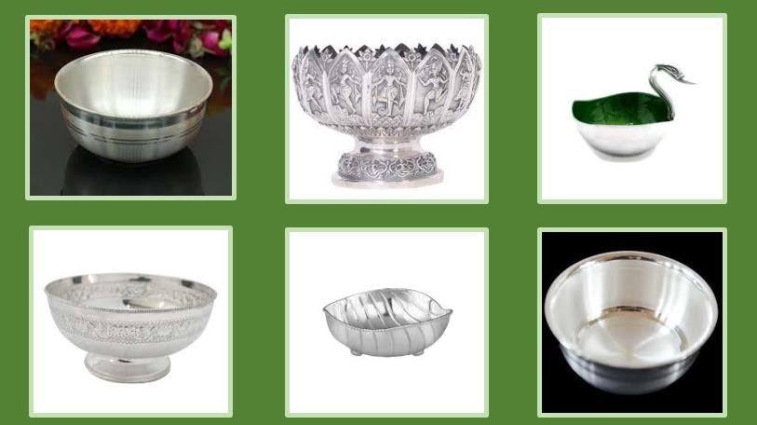

Range of Products – All type of Thali and Pooja articles

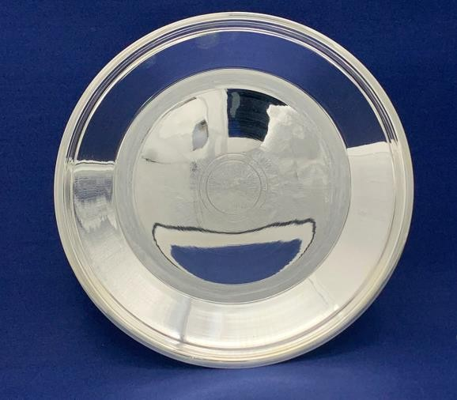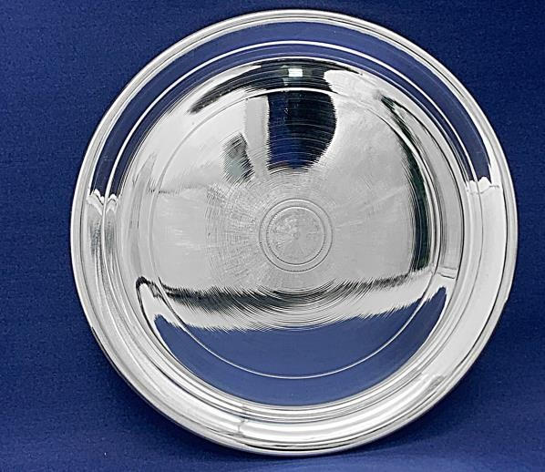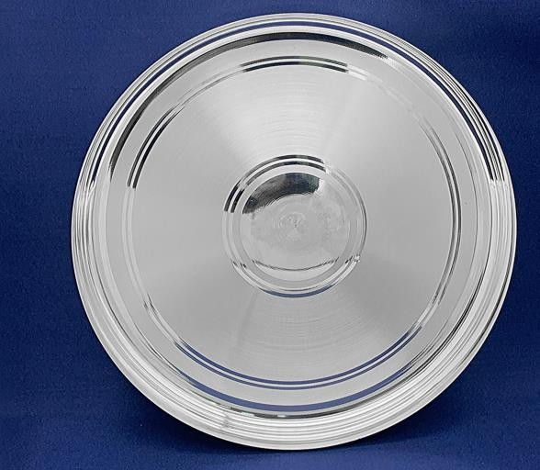

Range of Products – Variety of Silver Bags and articles

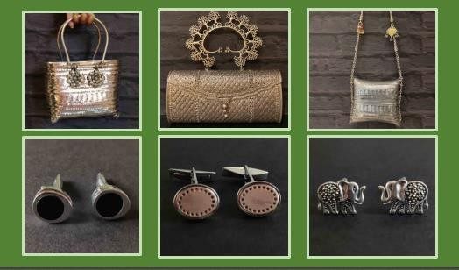

Range of Products – Variety of Nakshi design

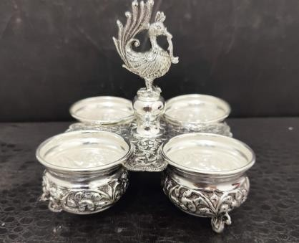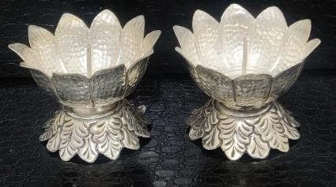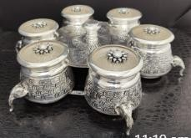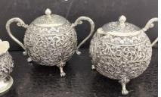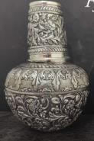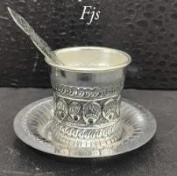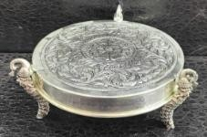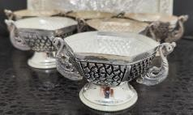

Range of Products



* + *All type of Pooja articles – Pooja Thali, Tamhan, Diya, Kalash, Lota, Ghanti, etc.*
  + *All type of God idols*
  + *Fancy gift articles from AED 50 and above*
  + *All types of Plates, Glasses, Bowls, Spoons, Forks, etc.*
  + *tfariety of Coins*
  + *24 Karat Gold Chain / Bangles / Kada*
  + *Authentic Pearls Jewellery*



# *Do visit us to explore variety of products…*

*Thank you!*